Association of Women in the Sciences
Income and Expenditure for Year Ending 31 March 2015

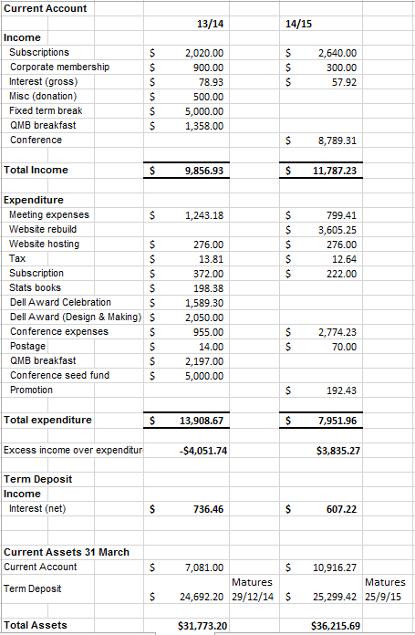
Financial Report for the Association for Women in the Science for the year ending
31 March 2015
AWIS finances remain in a very healthy state with $7951.96 in the current account, and $25,299.42 in term deposit. At maturity the interest from the term deposit is added to the principal and the total is reinvested for a similar term. Subscriptions were higher than last year as a result of increased activity from several regions. Expenditure was lower than last year but still higher than normal for several reasons:

- The AWIS website was rebuilt.
- Expenses from the 2014 conference, not paid in the previous financial year, included registration, travel and accommodation for the Dell Award Recipient, registration and travel for the AWIS Executive, and sundry expenses such as flowers and petrol vouchers for Dame Miriam Dell.
- Nelson and Canterbury regions each held an event, funded by AWIS.
- Emma is promoting AWIS through ads on Facebook. She also purchased music to accompany the video of Women in the Sciences produced from the 2014 Conference.
- AWIS stays subscribed to the New Zealand Association of Scientists and the National Council of Women.

- The seed money paid to the conference committee was repaid along with almost $4000 profit – a great effort from this committee.

I certify that this financial statement has been submitted and approved by the members at a general meeting held on the 11th day of July 2015.

Signed:
Name and designation:

