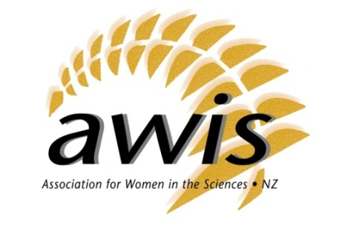
AWIS Convenor’s Report, 11 July 2015
Emma Timewell, National Convenor

AWIS had 129 members and 6 corporate members at the end of the 2014/15 year, broken down into regions:
- Auckland 28
- Christchurch 14
- Dunedin 15
- Manawatu 4
- Nelson 10
- Waikato 11
- Wellington 46

Wellington in particular has seen a significant increase in membership due to the 2014 conference being held at Victoria University Wellington in July 2014.

The 2014/15 year has been very busy for AWIS.

The eighth triennial conference – Absolutely Positively Science - saw 150 delegates, from across the science system, come together to discuss issues facing women in science and hear about some of the science being undertaken in New Zealand by successful scientists. I’d like to thank the conference organising committee – Cilla Wehi, Tracy Farr, Nicola Gaston, Natalie Plank and Sarah Wilcox – for their hardwork in putting on another really successful conference for the organisation.
We also got to wish our esteemed Patron, Dame Miriam Dell, a very happy 90th birthday during the conference proceedings. Luckily for us, Dame Miriam is still spry enough to attend our conference, and we appreciate her attendance and stories!

A relaunch of the Nelson region in February was very successful, and we thank Lauren Fletcher and Cawthron Institute for their support in re-establishing this local chapter. Auckland, Christchurch, Palmerston North, Wellington and Dunedin have also had several events over the course of the year, ranging from Q&A sessions for PhD students to networking dinners linked to public events.

For the first time, we held International Women’s Day events across the country in March, which was incredibly successful. Auckland, Palmerston North, Nelson, Dunedin and Christchurch all held events, including breakfasts, networking sessions and nature walks.

We also launched a new look AWIS website, and sent a submission to the Ministry of Business, Innovation & Employment on the new National Statement of Science Investment. Our Facebook and Twitter feeds have been buzzing with news and photos from across the regions, as well as from our international cousins, so is a great way of keeping in touch.

Thanks to all the Executive for their help and support, and particular thanks to Rachael Davidson, Lauren Fletcher, Ana Clarke, Esther Haines and Cilla Wehi who are all stepping down from the Executive this year. Michelle Thunders is also stepping down from her role as Newsletter Editor and we thank her for her help. I am very grateful for all the Executive’s commitment to AWIS over the time you’ve been part of it, whether it was one year or ten!

